# ASSINGMENT 1

Progress #1

#include <stdio.h>

#include <string.h>

int main() {

char player1[25], player2[25];//player name can't be longer than 25 characters and can't have space character

printf("*****************WELCOME!********************\n");

printf("*****************DRAUGHTS********************\n");

printf("\nEnter name of player 1:");

scanf("%s", player1);

printf("Enter name of player 2:");

scanf("%s", player2);

printf("\n***Good day %s and %s, let's start the game. All the best!!!***\n", player1, player2);

return 0;

}

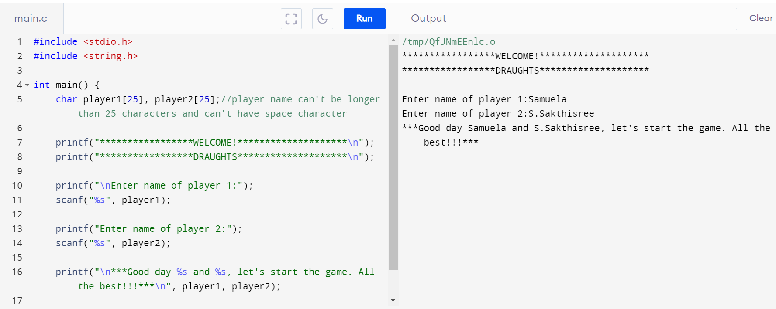

**Modified**

#include <stdio.h>

#include <string.h>

int main() {

char player1[25], player2[25];//player name can't be longer than 25 characters and can't have space character

printf("*****************WELCOME!********************\n");

printf("*****************DRAUGHTS********************\n");

printf("\nEnter name of player 1:");

scanf("%s", player1);

printf("Enter name of player 2:");

scanf("%s", player2);

printf("\n***Good day %s and %s, let's start the game. All the best!!!***\n", player1, player2);

printf("\n");

printf("\n# Objective: Capture Opponent's token");

printf("\n# Cutting of opponent's token: A player may jump one of his tokens onto one square occupied by his opponent's token.");

printf("\n# Captured token: The opponent's token is cut by the player's token and removed from the board.");

printf("\n# Points: Number of tokens cut by the player is the player's score.\n");

printf("\n*********************RULES***********************\n");

printf("*********************Please READ carefully***********************\n");

printf("\n1. Tokens move only along the diagonal squares in forward direction.");

printf("\n2. Tokens move only one square during each turn.");

printf("\n3. You can continue the game until you capture all opponent tokens or until you surrender.");

printf("\n4. Player's token is 'X', Opponent's token is 'O'.\n5. Each Player has 12 tokens on a 8*8 square board.\n");

printf("\n**************Press ENTER key to continue****************\n");

return 0;

}

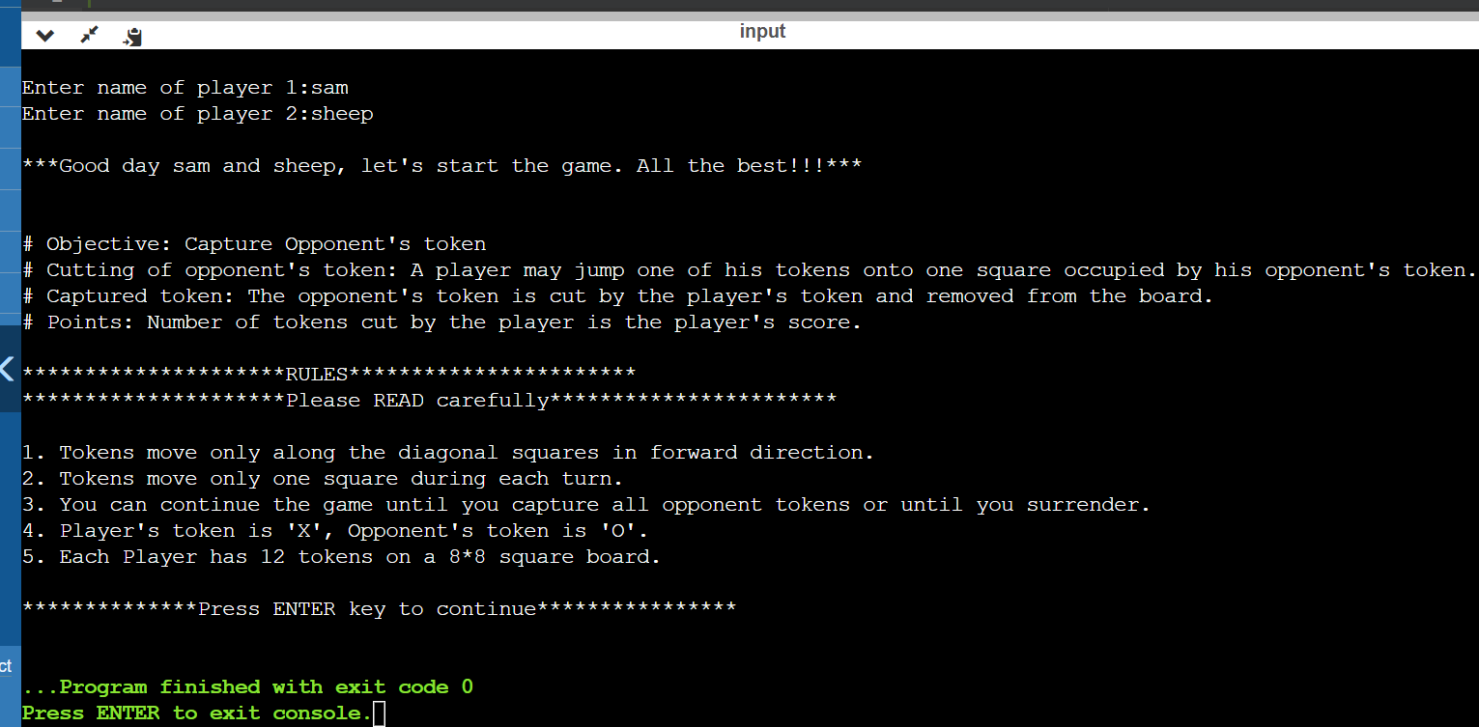

Progress #2

#include<stdio.h>

int main()

{

char a[8][8]= { {'X',' ','X',' ','X',' ','X',' '},

{' ','X',' ','X',' ','X',' ','X'},

{'X',' ','X',' ','X',' ','X',' '},

{' ',' ',' ',' ',' ',' ',' ',' '},

{' ',' ',' ',' ',' ',' ',' ',' '},

{' ','O',' ','O',' ','O',' ','O'},

{'O',' ','O',' ','O',' ','O',' '},

{' ','O',' ','O',' ','O',' ','O'} };

int i,j;

printf(" --- --- --- --- --- --- --- ---");

for(i=0;i<8;i++)

{

printf("\n");

for(j=0;j<8;j++)

{

printf("| %c ",a[i][j]);

}

printf("|\n");

if(i==0||i==1||i==2||i==3||i==4||i==5||i==6||i==7)

printf(" --- --- --- --- --- --- --- ---");

}

}

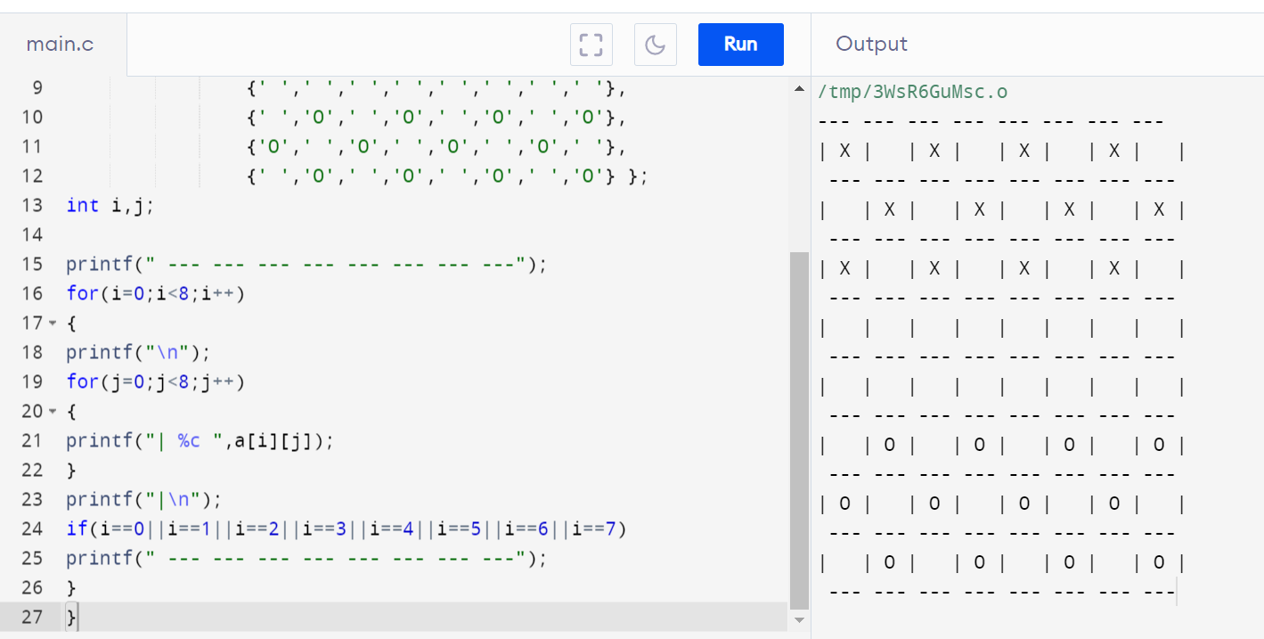

**Modified**

#include<stdio.h>

int main()

{

char a[8][8]={{'O',' ','O',' ','O',' ','O',' '},{' ','O',' ','O',' ','O',' ','O'},{'O',' ','O',' ','O',' ','O',' '},

{' ',' ',' ',' ',' ',' ',' ',' '},{' ',' ',' ',' ',' ',' ',' ',' '},

{' ','X',' ','X',' ','X',' ','X'},{'X',' ','X',' ','X',' ','X',' '},{' ','X',' ','X',' ','X',' ','X'}};

int i,j;

printf(" --- --- --- --- --- --- --- --- ");

for(i=0;i<8;i++)

{

printf(" \n");

for(j=0;j<8;j++)

{

printf("| %c ",a[i][j]);

}

printf("| %d \n",-(i-7));

if(i==0||i==1||i==2||i==3||i==4||i==5||i==6||i==7)

printf(" --- --- --- --- --- --- --- --- ");

}

printf("\n 0 1 2 3 4 5 6 7");

return 0;

}

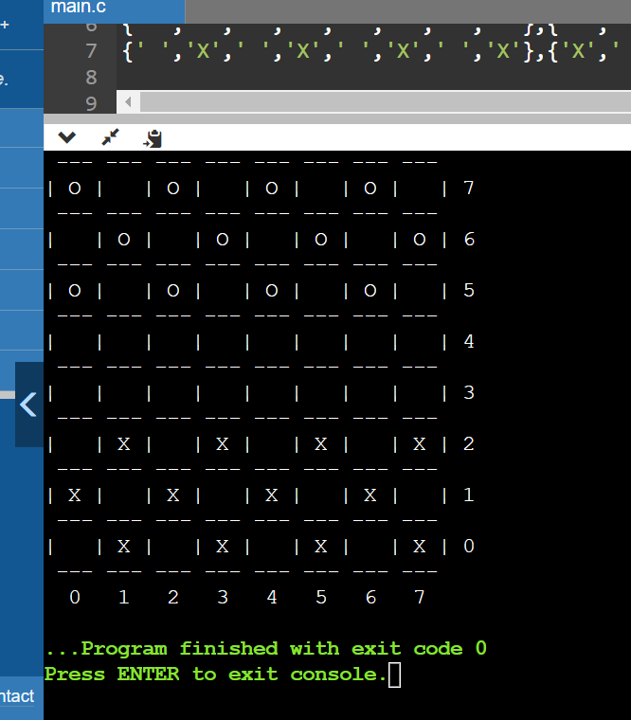

**Latest correct board**

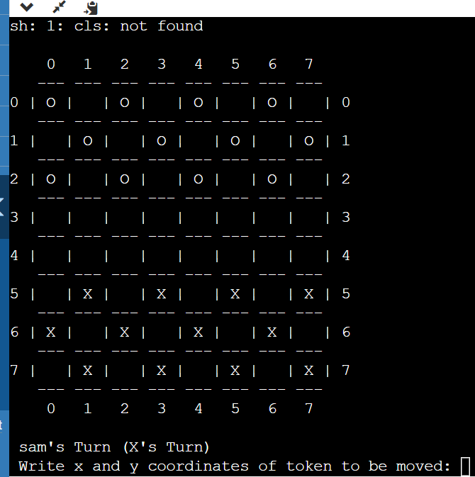

**Full #1**

#include <stdio.h>

#include <stdlib.h>

#include <string.h>

//coding for checker board and tokens using user-defined function

void draw_board(void)

{

char a[8][8]={{'X',' ','X',' ','X',' ','X',' '},{' ','X',' ','X',' ','X',' ','X'},{'X',' ','X',' ','X',' ','X',' '},

{' ',' ',' ',' ',' ',' ',' ',' '},{' ',' ',' ',' ',' ',' ',' ',' '},

{' ','O',' ','O',' ','O',' ','O'},{'O',' ','O',' ','O',' ','O',' '},{' ','O',' ','O',' ','O',' ','O'}};

int i,j;

printf(" --- --- --- --- --- --- --- --- ");

for(i=0;i<8;i++)

{

printf(" \n");

for(j=0;j<8;j++)

{

printf("| %c ",a[i][j]);

}

printf("| %d \n",-(i-7));

if(i==0||i==1||i==2||i==3||i==4||i==5||i==6||i==7)

printf(" --- --- --- --- --- --- --- --- ");

}

printf("\n 0 1 2 3 4 5 6 7");

}

int main() {

char player1[25], player2[25];//player name can't be longer than 25 characters and can't have space character

printf("*****************WELCOME!********************\n");

printf("*****************DRAUGHTS********************\n");

printf("\nEnter name of player 1:");

scanf("%s", player1);

printf("Enter name of player 2:");

scanf("%s", player2);

printf("\n***Good day %s and %s, let's start the game. All the best!!!***\n", player1, player2);

printf("\n");

draw_board();

return 0;

}

Progress #3

Clear screen example (works in codeblocks/TurboC compilers only)-

#include <stdio.h>

#include <stdlib.h>

int main(){

printf("Press any key to clear the screen\n");

printf("A B C D E F G H\n");

printf("1 \n 2 \n 3 \n 4 \n");

getchar();

system("cls"); // For Windows use system("cls");

printf("1 \n 2 \n 3 \n 4 \n");

printf("A B C D E F G H\n");

getchar();

return 0;

}

For GCC/G++ compilers in Linux

#include <stdio.h>

#include <stdlib.h> /*for system() function*/

void screen_clear(void){

//printf("\nPlease press ENTER key\n");

//getchar();

system("clear");

}

int main()

{

int num=100;

printf("Hello");

getchar();

/*Use after declaration section*/

//system("clear"); /*clear output screen*/

screen_clear();

printf("value of num: %d\n",num);

getchar();

return 0;

}

**Full #2**

#include <stdio.h>

#include <stdlib.h>

#include <string.h>

void screen_clear(void){

//printf("\nPlease press ENTER key\n");

//getchar();

system("clear");

}

//coding for checker board and tokens using user-defined function

void draw_board(void)

{

char checkers[8][8]={{'X',' ','X',' ','X',' ','X',' '},{' ','X',' ','X',' ','X',' ','X'},{'X',' ','X',' ','X',' ','X',' '},

{' ',' ',' ',' ',' ',' ',' ',' '},{' ',' ',' ',' ',' ',' ',' ',' '},

{' ','O',' ','O',' ','O',' ','O'},{'O',' ','O',' ','O',' ','O',' '},{' ','O',' ','O',' ','O',' ','O'}};

int i,j;

printf(" --- --- --- --- --- --- --- --- ");

for(i=0;i<8;i++)

{

printf(" \n");

for(j=0;j<8;j++)

{

printf("| %c ",checkers[i][j]);

}

printf("| %d \n",-(i-7));

if(i==0||i==1||i==2||i==3||i==4||i==5||i==6||i==7)

printf(" --- --- --- --- --- --- --- --- ");

}

printf("\n 0 1 2 3 4 5 6 7");

}

int main() {

char player1[25], player2[25];//player name can't be longer than 25 characters and can't have space character

printf("*****************WELCOME!********************\n");

printf("*****************DRAUGHTS********************\n");

printf("\nEnter name of player 1:");

scanf("%s", player1);

printf("Enter name of player 2:");

scanf("%s", player2);

getchar();

screen_clear();

printf("\n***Good day %s and %s, let's start the game. All the best!!!***\n", player1, player2);

printf("\n");

printf("\n# Objective: Capture Opponent's token");

printf("\n# Cutting of opponent's token: A player may jump one of his tokens onto one square occupied by his opponent's token.");

printf("\n# Captured token: The opponent's token is cut by the player's token and removed from the board.");

printf("\n# Points: Number of tokens cut by the player is the player's score.\n");

printf("\n*********************RULES***********************\n");

printf("*********************Please READ carefully***********************\n");

printf("\n1. Tokens move only along the diagonal squares in forward direction.");

printf("\n2. Tokens move only one square during each turn.");

printf("\n3. You can continue the game until you capture all opponent tokens or until you surrender.");

printf("\n4. Player's token is 'X', Opponent's token is 'O'.\n5. Each Player has 12 tokens on a 8*8 square board.\n");

printf("\n**************Press ENTER key to continue****************\n");

getchar();

screen_clear();

draw_board();

return 0;

}

Progress #4

Displaying player scores (Invalid Version)

#include <stdio.h>

#include <stdlib.h>

struct players

{

int SCORE;

char NAME[25];

}player[100],k;

void main()

{

int i,j,n;

printf("Enter no.of.players: ");

scanf("%d", &n);

printf("Enter player's NAME , SCORE\n");

for(i=0;i<n;i++)

{

scanf("%s %d", player[i].NAME,&player[i].SCORE);

}

for(i=0;i<n;i++)

{

for(j=0;j<n-1;j++)

{

if(player[j].SCORE<player[j+1].SCORE)

{

k=player[j];

player[j]=player[j+1];

player[j+1]=k;

}

}

}

printf("\nPlayers Score\n");

printf("\nRANK\t\t\tNAME\t\t\tSCORE\n");

printf("------------------------------------------------------------\n");

printf("TOP 3 PLAYERS \n");

for(i=0;i<n;i++)

{

if(i==3)

{

printf("---------------******************************---------------\n");

printf("%d\t\t\t%s\t\t\t%d\n",i+1,player[i].NAME,player[i].SCORE);

}

else

{

printf("%d\t\t\t%s\t\t\t%d\n",i+1,player[i].NAME,player[i].SCORE);

}

}

}

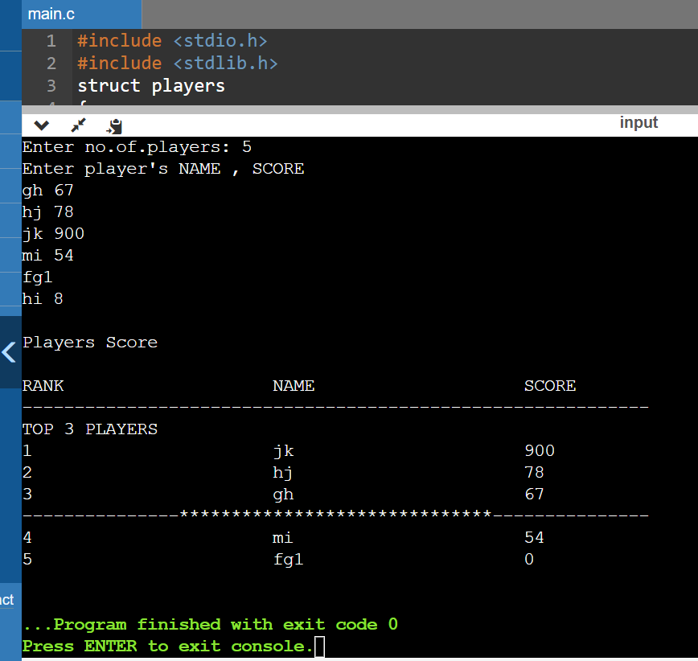

Progress #5

#include<stdio.h>  
#include <stdlib.h>  
#include <string.h>  
struct token{  
int token_p;    //for player  
int token_opp;  //for opponent  
};  
     char checkers[8][8]={  
        {'X',' ','X',' ','X',' ','X',' '},  
        {' ','X',' ','X',' ','X',' ','X'},  
        {'X',' ','X',' ','X',' ','X',' '},  
        {' ',' ',' ',' ',' ',' ',' ',' '},  
        {' ',' ',' ',' ',' ',' ',' ',' '},  
        {' ','O',' ','O',' ','O',' ','O'},  
        {'O',' ','O',' ','O',' ','O',' '},  
        {' ','O',' ','O',' ','O',' ','O'}  
        };  
//function to clear screen  
void screen_clear(void){  
     system("clear");  
 }  
  
 void move_O()//for opponent  
{  
    struct token old_x, old_y, new_x, new_y;  
  
  
    printf("Write x and y coordinates of token to be moved: ");  
    scanf("%d %d" ,&old_x.token_opp ,&old_y.token_opp);  
  
    printf("Write x and y coordinates of square where token is to be placed: ");  
    scanf("%d %d" ,&new_x.token_opp ,&new_y.token_opp);  
}  
  
void move_X(int x, int y,int new_x, int new_y)//for player  
{  
  
   int i,j;  
    printf(" --- --- --- --- --- --- --- --- ");  
    for(i=0;i<8;i++)  
    {  
        printf(" \n");  
        for(j=0;j<8;j++)  
        {  
            printf("| %c ",checkers[i][j]);  
        }  
        printf("| %d \n",-(i-7));  
        if(i==0||i==1||i==2||i==3||i==4||i==5||i==6||i==7)  
            printf(" --- --- --- --- --- --- --- --- ");  
        }  
        printf("\n  0   1   2   3   4   5   6   7");  
  
  
}  
  
void get_turn(int Turn, char *player1, char *player2){  
  
    struct token old_x, old_y, new_x, new_y;  
    for(Turn=1; ;Turn++)  
    {  
        if(Turn%2==0)  
        {  
            printf("\n %s's Turn (O's Turn)",player2);  
  
            move_O();  
        }  
        else{  
            printf("\n %s's Turn (X's Turn)",player1);  
            printf("\n Write x and y coordinates of token to be moved: ");  
            scanf("%d %d" ,&old_x.token_p ,&old_y.token_p);  
  
            printf("\n Write x and y coordinates of square where token is to be placed: ");  
            scanf("%d %d" ,&new_x.token_p ,&new_y.token_p);  
            move_X(old_x.token_p,old_y.token_p,new_x.token_p,new_y.token_p);  
        }  
  
    }  
}  
  
//9 9 is surrender code  
void end_game(struct token old_x, struct token old_y){  
    if(old_x.token_opp==9 && old_y.token_opp==9){  
        screen_clear();  
  
      printf("X won!");  
    }  
  
    else if(old_x.token_p==9 && old_y.token_p==9){  
        screen_clear();  
  
        printf("O won!");  
    }  
}  
  
  
/*************************************/  
  
  
//coding for checker board and tokens using user-defined function  
void draw_board(void)  
{  
  
    int i,j;  
    printf(" --- --- --- --- --- --- --- --- ");  
    for(i=0;i<8;i++)  
    {  
        printf(" \n");  
        for(j=0;j<8;j++)  
        {  
            printf("| %c ",checkers[i][j]);  
        }  
        printf("| %d \n",-(i-7));  
        if(i==0||i==1||i==2||i==3||i==4||i==5||i==6||i==7)  
            printf(" --- --- --- --- --- --- --- --- ");  
        }  
        printf("\n  0   1   2   3   4   5   6   7");  
}  
  
int main() {  
    char player1[25], player2[25];//player name can't be longer than 25 characters and can't have space character  
    int turn=1;  
    printf("*****************WELCOME!********************\n");  
    printf("*****************DRAUGHTS********************\n");  
  
    printf("\nEnter name of player 1:");  
    scanf("%s", player1);  
  
    printf("Enter name of player 2:");  
    scanf("%s", player2);  
  
    getchar();  
    screen_clear();  
  
    printf("\n***Good day %s and %s, let's start the game. All the best!!!***\n", player1, player2);  
    printf("\n");  
  
    printf("\n# Objective: Capture Opponent's token");  
    printf("\n# Cutting of opponent's token: A player may jump one of his tokens onto one square occupied by his opponent's token.");  
    printf("\n# Captured token: The opponent's token is cut by the player's token and removed from the board.");  
    printf("\n# Points: Number of tokens cut by the player is the player's score.\n");  
  
    printf("\n*********************RULES***********************\n");  
    printf("*********************Please READ carefully***********************\n");  
    printf("\n1. Tokens move only along the diagonal squares in forward direction.");  
    printf("\n2. Tokens move only one square during each turn.");  
    printf("\n3. You can continue the game until you capture all opponent tokens or until you surrender.");  
    printf("\n4. Player's token is 'X', Opponent's token is 'O'.\n5. Each Player has 12 tokens on a 8*8 square board.\n");  
    printf("\n**************Press ENTER key to continue****************\n");  
  
    getchar();  
    screen_clear();  
    draw_board();  
    get_turn(turn, player1, player2);  
    return 0;  
}

Progress #6

#include<stdio.h>  
#include <stdlib.h>  
#include <string.h>  
  
//Global variables  
char current_Player[25];//used to see which player won  
int end_flag=0;//used in end_game() function  
  
struct token{  
int x, y;// x and y coordinate  
};  
  
struct player{  
int count, current_flag;//count for score, and for whoever current_flag=1, that is current player  
char name[25];//name of player  
};  
  
     char checkers[8][8]={  
        {'O',' ','O',' ','O',' ','O',' '},  
        {' ','O',' ','O',' ','O',' ','O'},  
        {'O',' ','O',' ','O',' ','O',' '},  
        {' ',' ',' ',' ',' ',' ',' ',' '},  
        {' ',' ',' ',' ',' ',' ',' ',' '},  
        {' ','X',' ','X',' ','X',' ','X'},  
        {'X',' ','X',' ','X',' ','X',' '},  
        {' ','X',' ','X',' ','X',' ','X'}  
        };  
  
//function to clear screen  
void screen_clear(void){  
     system("cls");  
 }  
  
 //9 9 is surrender code  
int end_game(struct token old){  
    if(old.x==9 && old.y==9){  
        end_flag=1;  
        screen_clear();  
  
      printf("\nGAME OVER!\n");  
      printf("\n%s WON!\n",current_Player);  
    }  
    return end_flag;  
}  
  
 /*void move_O(int old_x, int old_y,int new_x, int new_y)//for opponent  
{  
    struct token old_x, old_y, new_x, new_y;  
  
  
    printf("Write x and y coordinates of token to be moved: ");  
    scanf("%d %d" ,&old_x.token_opp ,&old_y.token_opp);  
  
    printf("Write x and y coordinates of square where token is to be placed: ");  
    scanf("%d %d" ,&new_x.token_opp ,&new_y.token_opp);  
}*/  
  
void move_X(struct token old, struct token new)//for player  
{  
  
   int i,j;  
  
   if(end_game(old)==0)  
{  
        printf(" --- --- --- --- --- --- --- --- ");  
        for(i=0;i<8;i++)  
        {  
                printf(" \n");  
                for(j=0;j<8;j++)  
                {  
                    printf("| %c ",checkers[i][j]);  
                }  
                printf("| %d \n",-(i-7));  
                if(i==0||i==1||i==2||i==3||i==4||i==5||i==6||i==7)  
                    printf(" --- --- --- --- --- --- --- --- ");  
            }  
            printf("\n  0   1   2   3   4   5   6   7");  
   }  
  
}  
  
int get_turn(int Turn, struct player player_X, struct player player_O){  
  
    struct token old, new;  
    int rem =0;  
    for(Turn=1; ;Turn++)  
    {  
  
        if(Turn%2==0)  
        {  
            printf("\n %s's Turn (O's Turn)",player_O.name);  
  
            //move_O();  
        }  
        else{  
            printf("\n %s's Turn (X's Turn)",player_X.name);  
            printf("\n Write x and y coordinates of token to be moved: ");  
            scanf("%d %d" ,&old.x ,&old.y);  
  
            printf("\n Write x and y coordinates of square where token is to be placed: ");  
            scanf("%d %d" ,&new.x ,&new.y);  
            move_X(old, new);  
            rem = 1;  
        }  
  
    }  
    return rem;  
}  
  
  
  
  
/*************************************/  
  
  
//coding for checker board and tokens using user-defined function  
void draw_board(void)  
{  
  
    int i,j;  
    printf(" --- --- --- --- --- --- --- --- ");  
    for(i=0;i<8;i++)  
    {  
        printf(" \n");  
        for(j=0;j<8;j++)  
        {  
            printf("| %c ",checkers[i][j]);  
        }  
        printf("| %d \n",-(i-7));  
        if(i==0||i==1||i==2||i==3||i==4||i==5||i==6||i==7)  
            printf(" --- --- --- --- --- --- --- --- ");  
        }  
        printf("\n  0   1   2   3   4   5   6   7");  
}  
  
int main() {  
    //char player1[25], player2[25];  
    struct player player_X, player_O;  
    int turn=1;  
  
    printf("*****************WELCOME!********************\n");  
    printf("*****************DRAUGHTS********************\n");  
  
    printf("\nEnter name of player 1:");  
    scanf("%s", player_X.name);  
  
    printf("Enter name of player 2:");  
    scanf("%s", player_O.name);  
  
    getchar();  
    screen_clear();  
  
    printf("\n***Good day %s and %s, let's start the game. All the best!!!***\n", player_X.name, player_O.name);  
    printf("\n");  
  
    printf("\n# Objective: Capture Opponent's token");  
    printf("\n# Cutting of opponent's token: A player may jump one of his tokens onto one square occupied by his opponent's token.");  
    printf("\n# Captured token: The opponent's token is cut by the player's token and removed from the board.");  
    printf("\n# Points: Number of tokens cut by the player is the player's score.\n");  
  
    printf("\n*********************RULES***********************\n");  
    printf("*********************Please READ carefully***********************\n");  
    printf("\n1. Tokens move only along the diagonal squares in forward direction.");  
    printf("\n2. Tokens move only one square during each turn.");  
    printf("\n3. You can continue the game until you capture all opponent tokens or until you surrender.");  
    printf("\n4. Player 1's token is 'X', Player 2's token is 'O'.\n5. Each Player has 12 tokens on a 8*8 square board.\n");  
    printf("\n**************Press ENTER key to continue****************\n");  
  
    getchar();  
    screen_clear();  
  
    draw_board();  
  
  
    /* if (get_turn(turn, player_X, player_O) == 0){  
        strcpy(current_Player,player_X);  
    }  
    else{  
       strcpy(current_Player,player_O);  
    }  
       //puts(current_Player);  
       printf("%s",current_Player);*/  
  
    return 0;  
}

Progress #7

/*************************************************************************  
 * Welcome to draught programed by Samuela, Sakthi, Merlin, and Deepiga. *  
 *                                                                       *  
 *                           AI & DS Department                          *  
 *                    Coimbatore Institute of Technology                 *  
 *************************************************************************/  
  
  
#include <stdio.h>  
#include <stdlib.h>  
#include <string.h>  
  
//Global variables  
char current_Player[25];  
//char winner_Player[25];//used to see which player won  
int end_flag=0;//used in end_game() function  
  
struct token{  
int x, y;// x and y coordinate  
};  
  
struct player{  
int count;//count for score  
int current_flag;//for whoever current_flag=1, that is current player  
char name[25];//name of player  
};  
  
    struct player player_X, player_O;  
  
     char checkers[8][8]={  
        {'O',' ','O',' ','O',' ','O',' '},  
        {' ','O',' ','O',' ','O',' ','O'},  
        {'O',' ','O',' ','O',' ','O',' '},  
        {' ',' ',' ',' ',' ',' ',' ',' '},  
        {' ',' ',' ',' ',' ',' ',' ',' '},  
        {' ','X',' ','X',' ','X',' ','X'},  
        {'X',' ','X',' ','X',' ','X',' '},  
        {' ','X',' ','X',' ','X',' ','X'}  
        };  
  
  
  
/******************************************  
 * End of declaration of Global variables *  
 ******************************************/  
  
  
  
//function to clear screen  
void screen_clear(void){  
     system("cls");  
 }  
  
  
/**********************************  
 * End of screen_clear() function *  
 **********************************/  
  
  
  
//9 9 is surrender code  
int end_game(struct token old){  
  
    if(old.x==9 && old.y==9)  
    {  
        end_flag=1;  
        screen_clear();  
        printf("\nGAME OVER!\n");  
        if(strcmp(current_Player,player_X.name)==0)  
        {  
            printf("\n%s WON!\n",player_O.name);  
        }  
        else  
        {  
            printf("\n%s WON!\n",player_X.name);  
        }  
    }  
    return end_flag;  
}  
  
  
  
/******************************  
 * End of end_game() function *  
 ******************************/  
  
  
  
 void move_O(struct token old, struct token new)//for player2  
{  
    int i,j;  
  
   checkers[new.x][new.y]=checkers[old.x][old.y];  
   checkers[old.x][old.y]=' ';  
    strcpy(current_Player,player_O.name);  
   if(end_game(old)==0)  
    {  
        printf(" --- --- --- --- --- --- --- --- ");  
        for(i=0;i<8;i++)  
        {  
                printf(" \n");  
                for(j=0;j<8;j++)  
                {  
                    printf("| %c ",checkers[i][j]);  
                }  
                printf("| %d \n",-(i-7));  
                if(i==0||i==1||i==2||i==3||i==4||i==5||i==6||i==7)  
                    printf(" --- --- --- --- --- --- --- --- ");  
            }  
            printf("\n  0   1   2   3   4   5   6   7");  
   }  
  
   if(checkers[new.x][new.y]=='X')  
    player_O.count++;  
  
}  
  
  
  
/****************************  
 * End of move_O() function *  
 ****************************/  
  
  
  
void move_X(struct token old, struct token new)//for player1  
{  
    int i,j;  
    checkers[new.x][new.y]=checkers[old.x][old.y];  
    checkers[old.x][old.y]=' ';  
    strcpy(current_Player,player_X.name);  
    if(end_game(old)==0)  
    {  
        printf(" --- --- --- --- --- --- --- --- ");  
        for(i=0;i<8;i++)  
        {  
            printf(" \n");  
            for(j=0;j<8;j++)  
            {  
                printf("| %c ",checkers[i][j]);  
            }  
            printf("| %d \n",-(i-7));  
            if(i==0||i==1||i==2||i==3||i==4||i==5||i==6||i==7)  
            printf(" --- --- --- --- --- --- --- --- ");  
        }  
        printf("\n  0   1   2   3   4   5   6   7");  
    }  
    if(checkers[new.x][new.y]=='O')  
    player_X.count++;  
}  
  
  
  
/****************************  
 * End of move_X() function *  
 ****************************/  
  
  
  
int get_turn(int Turn, struct player player_X, struct player player_O){  
  
    struct token old, new;  
    int rem =0;  
    for(Turn=1; ;Turn++)  
    {  
        if(end_flag==1)  
            break;  
  
        if(Turn%2==0)  
        {  
            printf("\n %s's Turn (O's Turn)",player_O.name);  
            printf("\n Write x and y coordinates of token to be moved: ");  
            scanf("%d %d" ,&old.x ,&old.y);  
            printf("\n Write x and y coordinates of square where token is to be placed: ");  
            scanf("%d %d" ,&new.x ,&new.y);  
            move_O(old, new);  
        }  
        else  
        {  
            printf("\n %s's Turn (X's Turn)",player_X.name);  
            printf("\n Write x and y coordinates of token to be moved: ");  
            scanf("%d %d" ,&old.x ,&old.y);  
  
            printf("\n Write x and y coordinates of square where token is to be placed: ");  
            scanf("%d %d" ,&new.x ,&new.y);  
            move_X(old, new);  
            rem = 1;  
        }  
    }  
    return rem;  
}  
  
  
  
/******************************  
 * End of get_turn() function *  
 ******************************/  
  
  
  
//coding for checker board and tokens using user-defined function  
void draw_board(void)  
{  
  
    int i,j;  
    printf(" --- --- --- --- --- --- --- --- ");  
    for(i=0;i<8;i++)  
    {  
        printf(" \n");  
        for(j=0;j<8;j++)  
        {  
            printf("| %c ",checkers[i][j]);  
        }  
        printf("| %d \n",-(i-7));  
        if(i==0||i==1||i==2||i==3||i==4||i==5||i==6||i==7)  
            printf(" --- --- --- --- --- --- --- --- ");  
        }  
        printf("\n  0   1   2   3   4   5   6   7");  
}  
  
  
  
/********************************  
 * End of draw_board() function *  
 ********************************/  
  
  
  
/****************************  
 * Start of main() function *  
 ****************************/  
  
  
  
int main() {  
    //char player1[25], player2[25];  
  
    int turn=2;  
  
    printf("*****************WELCOME!********************\n");  
    printf("*****************DRAUGHTS********************\n");  
  
    printf("\nEnter name of player 1:");  
    scanf("%s", player_X.name);  
  
    printf("Enter name of player 2:");  
    scanf("%s", player_O.name);  
  
    getchar();  
    screen_clear();  
  
    printf("\n***Good day %s and %s, let's start the game. All the best!!!***\n", player_X.name, player_O.name);  
    printf("\n");  
  
    printf("\n# Objective: Capture Opponent's token");  
    printf("\n# Cutting of opponent's token: A player may jump one of his tokens onto one square occupied by his opponent's token.");  
    printf("\n# Captured token: The opponent's token is cut by the player's token and removed from the board.");  
    printf("\n# Points: Number of tokens cut by the player is the player's score.\n");  
  
    printf("\n*********************RULES***********************\n");  
    printf("*********************Please READ carefully***********************\n");  
    printf("\n1. Tokens move only along the diagonal squares in forward direction.");  
    printf("\n2. Tokens move only one square during each turn.");  
    printf("\n3. You can continue the game until you capture all opponent tokens or until you surrender.");  
    printf("\n4. Player 1's token is 'X', Player 2's token is 'O'.\n5. Each Player has 12 tokens on a 8*8 square board.\n");  
    printf("\n**************Press ENTER key to continue****************\n");  
  
    getchar();  
    screen_clear();  
  
    draw_board();  
    turn = get_turn(turn, player_X, player_O);  
  
  
    return 0;  
}

Progress #8

/*************************************************************************  
 * Welcome to draught programed by Samuela, Sakthi, Merlin, and Deepiga. *  
 *                                                                       *  
 *                           AI & DS Department                          *  
 *                    Coimbatore Institute of Technology                 *  
 *************************************************************************/  
  
  
#include <stdio.h>  
#include <stdlib.h>  
#include <string.h>  
  
//Global variables  
char current_Player[25];  
//char winner_Player[25];//used to see which player won  
int end_flag=0;//used in end_game() function  
  
struct token{  
int x, y;// x and y coordinate  
int king_flag; //for whoever king_flag=1, that token is king  
};  
//struct token token_X, token_O;  
  
struct player{  
int count;//count for score  
int current_flag;//for whoever current_flag=1, that is current player  
char name[25];//name of player  
};  
  
struct player player_X, player_O;  
  
 char checkers[8][8]={  
    {'O',' ','O',' ','O',' ','O',' '},  
    {' ','O',' ','O',' ','O',' ','O'},  
    {'O',' ','O',' ','O',' ','O',' '},  
    {' ',' ',' ',' ',' ',' ',' ',' '},  
    {' ',' ',' ',' ',' ',' ',' ',' '},  
    {' ','X',' ','X',' ','X',' ','X'},  
    {'X',' ','X',' ','X',' ','X',' '},  
    {' ','X',' ','X',' ','X',' ','X'}  
    };  
  
  
  
/******************************************  
 * End of declaration of Global variables *  
 ******************************************/  
  
  
  
//function to clear screen  
void screen_clear(void){  
     system("cls");  
 }  
  
/**********************************  
 * End of screen_clear() function *  
 **********************************/  
  
  
  
//9 9 is surrender code  
int end_game(struct token old){  
  
    if(old.x==9 && old.y==9)  
    {  
        end_flag=1;  
        screen_clear();  
        printf("\nGAME OVER!\n");  
        if(strcmp(current_Player,player_X.name)==0)  
        {  
            printf("\n%s WON!\n",player_O.name);  
        }  
        else  
        {  
            printf("\n%s WON!\n",player_X.name);  
        }  
    }  
    return end_flag;  
}  
  
  
  
/******************************  
 * End of end_game() function *  
 ******************************/  
  
  
//coding for checker board and tokens using user-defined function  
void draw_board(void)  
{  
  
    int i,j;  
        printf("\n    0   1   2   3   4   5   6   7 \n");  
        printf("   --- --- --- --- --- --- --- --- ");  
        for(i=0;i<8;i++)  
        {  
            printf(" \n%d ",i);  
            for(j=0;j<8;j++)  
            {  
                printf("| %c ",checkers[i][j]);  
            }  
            printf("| %d \n",i);  
            if(i==0||i==1||i==2||i==3||i==4||i==5||i==6||i==7)  
            printf("   --- --- --- --- --- --- --- --- ");  
        }  
        printf("\n    0   1   2   3   4   5   6   7 \n");  
}  
  
/********************************  
 * End of draw_board() function *  
 ********************************/  
  
  
  
 void move_O(struct token old, struct token new)//for player2  
{  
   checkers[new.x][new.y]=checkers[old.x][old.y];  
   checkers[old.x][old.y]=' ';  
  
   printf("\ncheckers[%d][%d]=%c \n",new.x,new.y,checkers[new.x][new.y]);  
   printf("checkers[%d][%d]=%c \n",old.x,old.y, checkers[old.x][old.y]);  
  
    strcpy(current_Player,player_O.name);  
   if(end_game(old)==0)  
    {  
        draw_board();  
   }  
  
   if(checkers[new.x][new.y]=='X')  
    player_O.count++;  
  
}  
  
  
  
/****************************  
 * End of move_O() function *  
 ****************************/  
  
  
  
void move_X(struct token old, struct token new)//for player1  
{  
    checkers[new.x][new.y]=checkers[old.x][old.y];  
    checkers[old.x][old.y]=' ';  
  
   printf("\ncheckers[%d][%d]=%c \n",new.x,new.y,checkers[new.x][new.y]);  
   printf("checkers[%d][%d]=%c \n",old.x,old.y, checkers[old.x][old.y]);  
  
    strcpy(current_Player,player_X.name);  
    if(end_game(old)==0)  
    {  
       draw_board();  
    }  
    if(checkers[new.x][new.y]=='O')  
    player_X.count++;  
}  
  
  
  
/****************************  
 * End of move_X() function *  
 ****************************/  
  
  
  
int get_turn(int Turn, struct player player_X, struct player player_O){  
  
    struct token old, new;  
    int rem =0;  
    for(Turn=1; ;Turn++)  
    {  
        if(end_flag==1)  
            break;  
  
        if(Turn%2==0)  
        {  
            printf("\n %s's Turn (O's Turn)",player_O.name);  
            printf("\n Write x and y coordinates of token to be moved: ");  
            scanf("%d %d" ,&old.x ,&old.y);  
            printf("\n Write x and y coordinates of square where token is to be placed: ");  
            scanf("%d %d" ,&new.x ,&new.y);  
            move_O(old, new);  
        }  
        else  
        {  
            printf("\n %s's Turn (X's Turn)",player_X.name);  
            printf("\n Write x and y coordinates of token to be moved: ");  
            scanf("%d %d" ,&old.x ,&old.y);  
  
            printf("\n Write x and y coordinates of square where token is to be placed: ");  
            scanf("%d %d" ,&new.x ,&new.y);  
            move_X(old, new);  
            rem = 1;  
        }  
    }  
    return rem;  
}  
  
  
  
/******************************  
 * End of get_turn() function *  
 ******************************/  
  
  
  
  
  
/****************************  
 * Start of main() function *  
 ****************************/  
  
  
  
int main() {  
    //char player1[25], player2[25];  
  
    int turn=2;  
  
    printf("*****************WELCOME!********************\n");  
    printf("*****************DRAUGHTS********************\n");  
  
    printf("\nEnter name of player 1:");  
    scanf("%s", player_X.name);  
  
    printf("Enter name of player 2:");  
    scanf("%s", player_O.name);  
  
    getchar();  
    screen_clear();  
  
    printf("\n***Good day %s and %s, let's start the game. All the best!!!***\n", player_X.name, player_O.name);  
    printf("\n");  
  
    printf("\n# Objective: Capture Opponent's token");  
    printf("\n# Cutting of opponent's token: A player may jump one of his tokens onto one square occupied by his opponent's token.");  
    printf("\n# Captured token: The opponent's token is cut by the player's token and removed from the board.");  
    printf("\n# Points: Number of tokens cut by the player is the player's score.\n");  
  
    printf("\n*********************RULES***********************\n");  
    printf("*********************Please READ carefully***********************\n");  
    printf("\n1. Tokens move only along the diagonal squares in forward direction.");  
    printf("\n2. Tokens move only one square during each turn.");  
    printf("\n3. You can continue the game until you capture all opponent tokens or until you surrender.");  
    printf("\n4. Player 1's token is 'X', Player 2's token is 'O'.\n5. Each Player has 12 tokens on a 8*8 square board.\n");  
    printf("\n**************Press ENTER key to continue****************\n");  
  
    getchar();  
    screen_clear();  
  
    draw_board();  
    turn = get_turn(turn, player_X, player_O);  
  
  
    return 0;  
}

Progress #9

Colored text (for GCC/G++)

#include <stdio.h>

void red(){

printf("\033[1;31m");

}

void reset();

int main()

{

red();

printf("Hello World");

return 0;

}

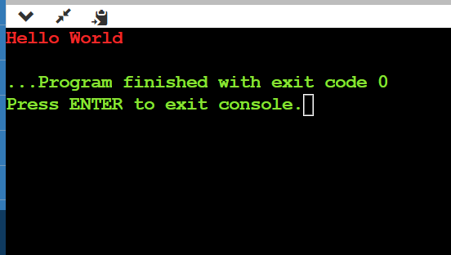

NOTE:- Reason why x and y are reverse in program (because of way in array, look below)

Rows are actually Y-axis, and columns are X-axis

So x[0][0], x[0][1], x[0][2] are actually reverse.

Like x[0][1] is x[row 0 (y coordinate or coordinate on y-axis)][column 1(x coordinate or coordinate on x-axis)]

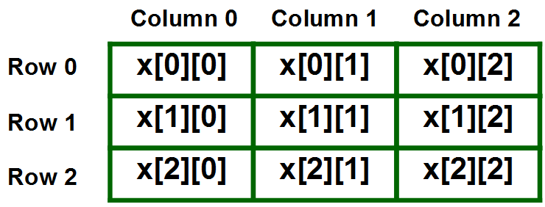

Progress #10

/*************************************************************************  
 * Welcome to draught programed by Samuela, Sakthi, Merlin, and Deepiga. *  
 *                                                                       *  
 *                           AI & DS Department                          *  
 *                    Coimbatore Institute of Technology                 *  
 *************************************************************************/  
  
  
#include <stdio.h>  
#include <stdlib.h>  
#include <string.h>  
  
//Global variables  
char current_Player[25];  
//char winner_Player[25];//used to see which player won  
int end_flag=0;//used in end_game() function  
int help_flag=0;//used in end_game() function  
  
struct token{  
int x, y;// x and y coordinate  
int king_flag; //for whoever king_flag=1, that token is king  
};  
//struct token token_X, token_O;  
  
struct player{  
int count;//count for score  
int current_flag;//for whoever current_flag=1, that is current player  
char name[25];//name of player  
};  
  
struct player player_X, player_O;  
  
 char checkers[8][8]={  
    {'O',' ','O',' ','O',' ','O',' '},  
    {' ','O',' ','O',' ','O',' ','O'},  
    {'O',' ','O',' ','O',' ','O',' '},  
    {' ',' ',' ',' ',' ',' ',' ',' '},  
    {' ',' ',' ',' ',' ',' ',' ',' '},  
    {' ','X',' ','X',' ','X',' ','X'},  
    {'X',' ','X',' ','X',' ','X',' '},  
    {' ','X',' ','X',' ','X',' ','X'}  
    };  
  
  
  
/******************************************  
 * End of declaration of Global variables *  
 ******************************************/  
  
  
  
/***********************************  
 * Start of colored text functions *  
 ***********************************/  
  
  
//red color  
void red(){  
    printf("\033[1;31m");  
}  
void reset();  
  
  
  
//green color  
void green(){  
    printf("\033[1;32m");  
}  
void reset();  
  
  
  
//yellow color  
void yellow(){  
    printf("\033[1;33m");  
}  
void reset();  
  
  
  
//blue color  
void blue(){  
    printf("\033[1;34m");  
}  
void reset();  
  
  
  
//purple color  
void purple(){  
    printf("\033[1;35m");  
}  
void reset();  
  
  
  
//cyan color  
void cyan(){  
    printf("\033[1;36m");  
}  
void reset();  
  
  
  
  
/*********************************  
 * End of colored text functions *  
 *********************************/  
  
  
  
/*************************************  
 * START of IMPORTANT game functions *  
 *************************************/  
  
  
  
//function to clear screen. Use cls for TurboC and clear for GCC/G++  
void screen_clear(void){  
     system("cls");  
 }  
  
/**********************************  
 * End of screen_clear() function *  
 **********************************/  
  
  
  
//9 9 is surrender code  
int end_game(struct token old){  
  
    if(old.x==9 && old.y==9)  
    {  
        end_flag=1;  
        screen_clear();  
  
        red();  
        printf("\nGAME OVER!\n");  
        //reset();  
  
        cyan();  
        if(strcmp(current_Player,player_X.name)==0)  
        {  
            printf("\n%s WON!\n",player_O.name);  
            printf("\nScore of %s is %d\n",player_O.name, player_O.count);  
        }  
        else  
        {  
            printf("\n%s WON!\n",player_X.name);  
            printf("\nScore of %s is %d\n",player_X.name, player_X.count);  
        }  
    }  
    return end_flag;  
}  
  
  
  
/******************************  
 * End of end_game() function *  
 ******************************/  
  
  
//8 8 is help code  
int help(struct token old){  
  
    if(old.x==8 && old.y==8)  
    {  
        help_flag=1;  
        yellow();  
    printf("\n**************************RULES*****************************\n");  
    printf("*********************Please READ carefully***********************\n");  
    printf("\n1. Tokens move only along the diagonal squares in forward direction.");  
    printf("\n2. Tokens move only one square during each turn.");  
    printf("\n3. You can continue the game until you capture all opponent tokens or until you surrender.");  
    printf("\n4. Player 1's token is 'X', Player 2's token is 'O'.\n5. Each Player has 12 tokens on a 8*8 square board.");  
    printf("\n6. Row number and column number will be displayed on all 4 corners of the board. Enter coordinates accordingly went prompted.");  
    printf("\n7. Enter 9 9 as token coordinates to surrender.\n8. Enter 99 99 as token coordinates for help menu.\n");  
    printf("\n**************Press ENTER key to continue****************\n");  
    }  
    return help_flag;  
}  
  
  
  
/**************************  
 * End of help() function *  
 **************************/  
  
  
  
//coding for checker board and tokens using user-defined function  
void draw_board(void)  
{  
  
    int i,j;  
        printf("\n    0   1   2   3   4   5   6   7 \n");  
        printf("   --- --- --- --- --- --- --- --- ");  
        for(i=0;i<8;i++)  
        {  
            printf(" \n%d ",i);  
            for(j=0;j<8;j++)  
            {  
                printf("| %c ",checkers[i][j]);  
            }  
            printf("| %d \n",i);  
            if(i==0||i==1||i==2||i==3||i==4||i==5||i==6||i==7)  
            printf("   --- --- --- --- --- --- --- --- ");  
        }  
        printf("\n    0   1   2   3   4   5   6   7 \n");  
}  
  
/********************************  
 * End of draw_board() function *  
 ********************************/  
  
  
  
 void move_O(struct token old, struct token new)//for player2  
{  
   checkers[new.y][new.x]=checkers[old.y][old.x];  
   checkers[old.y][old.x]=' ';  
  
   printf("\ncheckers[%d][%d]=%c \n",new.y,new.x,checkers[new.y][new.x]);  
   printf("checkers[%d][%d]=%c \n",old.y,old.x, checkers[old.y][old.x]);  
  
    strcpy(current_Player,player_O.name);  
   if(end_game(old)==0)  
    {  
        green();  
        draw_board();  
   }  
  
   if(checkers[new.y][new.x]=='X')  
    player_O.count++;  
  
}  
  
  
  
/****************************  
 * End of move_O() function *  
 ****************************/  
  
  
  
void move_X(struct token old, struct token new)//for player1  
{  
    checkers[new.y][new.x]=checkers[old.y][old.x];  
    checkers[old.y][old.x]=' ';  
  
   printf("\ncheckers[%d][%d]=%c \n",new.y,new.x,checkers[new.y][new.x]);  
   printf("checkers[%d][%d]=%c \n",old.y,old.x, checkers[old.y][old.x]);  
  
    strcpy(current_Player,player_X.name);  
    if(end_game(old)==0)  
    {  
       green();  
       draw_board();  
    }  
  
    if(checkers[new.y][new.x]=='O')  
    player_X.count++;  
}  
  
  
  
/****************************  
 * End of move_X() function *  
 ****************************/  
  
  
  
int get_turn(int Turn, struct player player_X, struct player player_O){  
  
    struct token old, new;  
    int rem =0;  
    for(Turn=1; ;Turn++)  
    {  
        if(end_flag==1)  
            break;  
  
        if(Turn%2==0)  
        {  
            purple();  
            printf("\n %s's Turn (O's Turn)",player_O.name);  
            printf("\n Write x and y coordinates of token to be moved: ");  
            scanf("%d %d" ,&old.x ,&old.y);  
            printf("\n Write x and y coordinates of square where token is to be placed: ");  
            scanf("%d %d" ,&new.x ,&new.y);  
  
                if(help(old))  
                {  
                    //help(old);  
                    help_flag=0;  
                    purple();  
                    printf("\n %s's Turn (O's Turn)",player_O.name);  
                    printf("\n Write x and y coordinates of token to be moved: ");  
                    scanf("%d %d" ,&old.y ,&old.x);  
                    printf("\n Write x and y coordinates of square where token is to be placed: ");  
                    scanf("%d %d" ,&new.y ,&new.x);  
                    move_O(old, new);  
                }  
            move_O(old, new);  
        }  
        else  
        {  
            purple();  
            printf("\n %s's Turn (X's Turn)",player_X.name);  
            printf("\n Write x and y coordinates of token to be moved: ");  
            scanf("%d %d" ,&old.y ,&old.x);  
  
            printf("\n Write x and y coordinates of square where token is to be placed: ");  
            scanf("%d %d" ,&new.y ,&new.x);  
  
                if(help(old))  
                {  
                    //help(old);  
                    help_flag=0;  
                    purple();  
                    printf("\n %s's Turn (X's Turn)",player_X.name);  
                    printf("\n Write x and y coordinates of token to be moved: ");  
                    scanf("%d %d" ,&old.y ,&old.x); //player enters coordinates of x and y, but in 2-D array it's reverse  
  
                    printf("\n Write x and y coordinates of square where token is to be placed: ");  
                    scanf("%d %d" ,&new.y ,&new.x);  
                    move_X(old, new);  
  
                }  
            move_X(old, new);  
            rem = 1;  
        }  
    }  
    return rem;  
}  
  
  
  
/******************************  
 * End of get_turn() function *  
 ******************************/  
  
  
  
/***********************************  
 * END of IMPORTANT game functions *  
 ***********************************/  
  
  
  
/****************************  
 * Start of main() function *  
 ****************************/  
  
  
  
int main() {  
    //char player1[25], player2[25];  
  
    int turn=2;  
  
    printf("\n**************Press ENTER key to Start Game****************\n");  
    getchar();  
    screen_clear();  
  
    cyan();  
    printf("*****************WELCOME!********************\n");  
    printf("*****************DRAUGHTS********************\n");  
  
    printf("\nEnter name of player 1:");  
    scanf("%s", player_X.name);  
  
    printf("Enter name of player 2:");  
    scanf("%s", player_O.name);  
  
    getchar();  
    screen_clear();  
  
    red();  
    printf("\n***Good day %s and %s, let's start the game. All the best!!!***\n", player_X.name, player_O.name);  
    printf("\n");  
  
    blue();  
    printf("\n# Objective: Capture Opponent's token");  
    printf("\n# Cutting of opponent's token: A player may jump one of his tokens onto one square occupied by his opponent's token.");  
    printf("\n# Captured token: The opponent's token is cut by the player's token and removed from the board.");  
    printf("\n# Points: Number of tokens cut by the player is the player's score.\n");  
    printf("\n**************Press ENTER key to continue****************\n");  
  
    getchar();  
    screen_clear();  
  
    green();  
    printf("\n**************************RULES****************************\n");  
    printf("*********************Please READ carefully***********************\n");  
    printf("\n1. Tokens move only along the diagonal squares in forward direction.");  
    printf("\n2. Tokens move only one square during each turn.");  
    printf("\n3. You can continue the game until you capture all opponent tokens or until you surrender.");  
    printf("\n4. Player 1's token is 'X', Player 2's token is 'O'.\n5. Each Player has 12 tokens on a 8*8 square board.");  
    printf("\n6. Row number and column number will be displayed on all 4 corners of the board. Enter coordinates accordingly went prompted.");  
    printf("\n7. Enter 9 9 as token coordinates to surrender.\n8. Enter 99 99 as token coordinates for help menu.\n");  
    printf("\n**************Press ENTER key to continue****************\n");  
  
    getchar();  
    screen_clear();  
  
    draw_board();  
    turn = get_turn(turn, player_X, player_O);  
  
    return 0;  
}

Progress #11

/*************************************************************************

* Welcome to draught programed by Samuela, Sakthi, Merlin, and Deepiga. *

* *

* AI & DS Department *

* Coimbatore Institute of Technology *

*************************************************************************/

#include <stdio.h>

#include <stdlib.h>

#include <string.h>

//Global variables

char current_Player[25];

int end_flag=0;//used in end_game() function

int help_flag=0;//used in help() function

struct token{

int row, col;// y-axis and x-axis coordinate

int king_flag; //for whoever king_flag=1, that token is king

};

struct player{

int count;//count for score

int current_flag;//for whoever current_flag=1, that is current player

char name[25];//name of player

};

struct player player_X, player_O;

char checkers[8][8]={

{'O',' ','O',' ','O',' ','O',' '},

{' ','O',' ','O',' ','O',' ','O'},

{'O',' ','O',' ','O',' ','O',' '},

{' ',' ',' ',' ',' ',' ',' ',' '},

{' ',' ',' ',' ',' ',' ',' ',' '},

{' ','X',' ','X',' ','X',' ','X'},

{'X',' ','X',' ','X',' ','X',' '},

{' ','X',' ','X',' ','X',' ','X'}

};

/******************************************

* End of declaration of Global variables *

******************************************/

/***********************************

* Start of colored text functions *

***********************************/

//red color

void red(){

printf("\033[1;31m");

}

void reset();

//green color

void green(){

printf("\033[1;32m");

}

void reset();

//yellow color

void yellow(){

printf("\033[1;33m");

}

void reset();

//blue color

void blue(){

printf("\033[1;34m");

}

void reset();

//purple color

void purple(){

printf("\033[1;35m");

}

void reset();

//cyan color

void cyan(){

printf("\033[1;36m");

}

void reset();

/*********************************

* End of colored text functions *

*********************************/

/*************************************

* START of IMPORTANT game functions *

*************************************/

//function to clear screen. Use cls for TurboC and clear for GCC/G++

void screen_clear(void){

system("cls");

}

/**********************************

* End of screen_clear() function *

**********************************/

//ends game and program exits with exit code

int end_game(struct token old){

//9 9 is surrender code

if(old.row==9 && old.col==9)

{

end_flag=1;

screen_clear();

red();

printf("\nGAME OVER!\n");

cyan();

if(strcmp(current_Player,player_X.name)==0)

{

printf("\n%s WON!\n",player_O.name);

printf("\nScore of %s is %d\n",player_O.name, player_O.count);

}

else

{

printf("\n%s WON!\n",player_X.name);

printf("\nScore of %s is %d\n",player_X.name, player_X.count);

}

}

//player 2 captured all X tokens, so game over

else if(player_O.count==12)

{

end_flag=1;

screen_clear();

red();

printf("\nGAME OVER!\n");

cyan();

printf("\n%s WON!\n",player_O.name);

printf("\nScore of %s is %d\n",player_O.name, player_O.count);

}

//player 1 captured all O tokens, so game over

else if(player_X.count==12)

{

end_flag=1;

screen_clear();

red();

printf("\nGAME OVER!\n");

cyan();

printf("\n%s WON!\n",player_X.name);

printf("\nScore of %s is %d\n",player_X.name, player_X.count);

}

return end_flag;

}

/******************************

* End of end_game() function *

******************************/

//8 8 is help code

int help(struct token old){

if(old.row==8 && old.col==8)

{

help_flag=1;

yellow();

printf("\n**************************RULES*****************************\n");

printf("*********************Please READ carefully***********************\n");

printf("\n1. Tokens move only along the diagonal squares in forward direction.");

printf("\n2. Tokens move only one square during each turn.");

printf("\n3. You can continue the game until you capture all opponent tokens or until you surrender.");

printf("\n4. Player 1's token is 'X', Player 2's token is 'O'.\n5. Each Player has 12 tokens on a 8x8 square board.");

printf("\n6. Row number with prefix r and column number with prefix c will be displayed on all 4 corners of the board.\n Enter coordinates accordingly when prompted.");

printf("\n7. Enter 9 9 as token coordinates to surrender.\n8. Enter 8 8 as token coordinates for help menu.\n");

printf("\n**************Press ENTER key to continue****************\n");

}

return help_flag;

}

/**************************

* End of help() function *

**************************/

//coding for checker board and tokens using user-defined function

void draw_board(void)

{

int i,j;

printf("\n c0 c1 c2 c3 c4 c5 c6 c7 \n");

printf(" --- --- --- --- --- --- --- --- ");

for(i=0;i<8;i++)

{

printf(" \nr%d ",i);

for(j=0;j<8;j++)

{

printf("| %c ",checkers[i][j]);

}

printf("| r%d \n",i);

if(i==0||i==1||i==2||i==3||i==4||i==5||i==6||i==7)

printf(" --- --- --- --- --- --- --- --- ");

}

printf("\n c0 c1 c2 c3 c4 c5 c6 c7 \n");

}

/********************************

* End of draw_board() function *

********************************/

void move_O(struct token old, struct token new)//for player2

{

checkers[new.row][new.col]=checkers[old.row][old.col];

checkers[old.row][old.col]=' ';

printf("\n new checkers[%d][%d]=%c \n",new.row,new.col,checkers[new.row][new.col]);

printf("old checkers[%d][%d]=%c \n",old.row,old.col, checkers[old.row][old.col]);

strcpy(current_Player,player_O.name);

if(end_game(old)==0)

{

green();

draw_board();

}

if(checkers[new.row][new.col]=='X')

player_O.count++;

}

/****************************

* End of move_O() function *

****************************/

void move_X(struct token old, struct token new)//for player1

{

checkers[new.row][new.col]=checkers[old.row][old.col];

checkers[old.row][old.col]=' ';

printf("\n new checkers[%d][%d]=%c \n",new.row,new.col,checkers[new.row][new.col]);

printf("old checkers[%d][%d]=%c \n",old.row,old.col, checkers[old.row][old.col]);

strcpy(current_Player,player_X.name);

if(end_game(old)==0)

{

green();

draw_board();

}

if(checkers[new.row][new.col]=='O')

player_X.count++;

}

/****************************

* End of move_X() function *

****************************/

int get_turn(int Turn, struct player player_X, struct player player_O){

struct token old, new;

int rem =0;

for(Turn=1; ;Turn++)

{

if(end_flag==1)

break;

if(Turn%2==0)

{

purple();

printf("\n %s's Turn (O's Turn)",player_O.name);

printf("\n Write row number and column number of token to be moved: ");

scanf("%d %d" ,&old.row ,&old.col);

printf("\n Write row number and column number of square where token is to be placed: ");

scanf("%d %d" ,&new.row ,&new.col);

if(help(old))

{

//help(old);

help_flag=0;

purple();

printf("\n %s's Turn (O's Turn)",player_O.name);

printf("\n Write row number and column number of token to be moved: ");

scanf("%d %d" ,&old.row ,&old.col);

printf("\n Write row number and column number of square where token is to be placed: ");

scanf("%d %d" ,&new.row ,&new.col);

move_O(old, new);

}

move_O(old, new);

}

else

{

purple();

printf("\n %s's Turn (X's Turn)",player_X.name);

printf("\n Write row number and column number of token to be moved: ");

scanf("%d %d" ,&old.row ,&old.col);

printf("\n Write row number and column number of square where token is to be placed: ");

scanf("%d %d" ,&new.row ,&new.col);

if(help(old))

{

help_flag=0;

purple();

printf("\n %s's Turn (X's Turn)",player_X.name);

printf("\n Write row number and column number of token to be moved: ");

scanf("%d %d" ,&old.row ,&old.col);

printf("\n Write row number and column number of square where token is to be placed: ");

scanf("%d %d" ,&new.row ,&new.col);

move_X(old, new);

}

move_X(old, new);

rem = 1;

}

}

return rem;

}

/******************************

* End of get_turn() function *

******************************/

/***********************************

* END of IMPORTANT game functions *

***********************************/

/****************************

* Start of main() function *

****************************/

int main() {

//char player1[25], player2[25];

int turn=2;

printf("\n**************Press ENTER key to Start Game****************\n");

getchar();

screen_clear();

cyan();

printf("*****************WELCOME!********************\n");

printf("*****************DRAUGHTS********************\n");

printf("\nEnter name of player 1:");

scanf("%s", player_X.name);

printf("Enter name of player 2:");

scanf("%s", player_O.name);

getchar();

screen_clear();

red();

printf("\n***Good day %s and %s, let's start the game. All the best!!!***\n", player_X.name, player_O.name);

printf("\n");

blue();

printf("\n# Objective: Capture Opponent's token");

printf("\n# Cutting of opponent's token: A player may jump one of his tokens onto one square occupied by his opponent's token.");

printf("\n# Captured token: The opponent's token is cut by the player's token and removed from the board.");

printf("\n# Points: Number of tokens cut by the player is the player's score.\n");

printf("\n**************Press ENTER key to continue****************\n");

getchar();

screen_clear();

green();

printf("\n**************************RULES****************************\n");

printf("*********************Please READ carefully***********************\n");

printf("\n1. Tokens move only along the diagonal squares in forward direction.");

printf("\n2. Tokens move only one square during each turn.");

printf("\n3. You can continue the game until you capture all opponent tokens or until you surrender.");

printf("\n4. Player 1's token is 'X', Player 2's token is 'O'.\n5. Each Player has 12 tokens on a 8x8 square board.");

printf("\n6. Row number with prefix r and column number with prefix c will be displayed on all 4 corners of the board.\n Enter coordinates accordingly when prompted.");

printf("\n7. Enter 9 9 as token coordinates to surrender.\n8. Enter 8 8 as token coordinates for help menu.\n");

printf("\n**************Press ENTER key to continue****************\n");

getchar();

screen_clear();

draw_board();

turn = get_turn(turn, player_X, player_O);

return 0;

}

Progress #12

/*************************************************************************

* Welcome to draught programed by Samuela, Sakthi, Merlin, and Deepiga. *

* *

* AI & DS Department *

* Coimbatore Institute of Technology *

*************************************************************************/

#include <stdio.h>

#include <stdlib.h>

#include <string.h>

//Global variables

char current_Player[25];

int end_flag=0;//used in end_game() function

int help_flag=0;//used in help() function

int check_flag_X=0;//if it's set to 1, then move made by player 1 is invalid

int check_flag_O=0;//if it's set to 1, then move made by player 2 is invalid

int king_flag=0; //for whoever king_flag=1, that token is king

struct token{

int row, col;// y-axis and x-axis coordinate

};

struct player{

int count;//count for score

char name[25];//name of player

};

struct player player_X, player_O;

char checkers[8][8]={

{'O',' ','O',' ','O',' ','O',' '},

{' ','O',' ','O',' ','O',' ','O'},

{'O',' ','O',' ','O',' ','O',' '},

{' ',' ',' ',' ',' ',' ',' ',' '},

{' ',' ',' ',' ',' ',' ',' ',' '},

{' ','X',' ','X',' ','X',' ','X'},

{'X',' ','X',' ','X',' ','X',' '},

{' ','X',' ','X',' ','X',' ','X'}

};

/******************************************

* End of declaration of Global variables *

******************************************/

/***********************************

* Start of colored text functions *

***********************************/

//red color

void red(){

printf("\033[1;31m");

}

void reset();

//green color

void green(){

printf("\033[1;32m");

}

void reset();

//yellow color

void yellow(){

printf("\033[1;33m");

}

void reset();

//blue color

void blue(){

printf("\033[1;34m");

}

void reset();

//purple color

void purple(){

printf("\033[1;35m");

}

void reset();

//cyan color

void cyan(){

printf("\033[1;36m");

}

void reset();

/*********************************

* End of colored text functions *

*********************************/

/*************************************

* START of IMPORTANT game functions *

*************************************/

//function to clear screen. Use cls for TurboC and clear for GCC/G++

void screen_clear(void){

system("cls");

}

/**********************************

* End of screen_clear() function *

**********************************/

//ends game and program exits with exit code

int end_game(struct token old){

//9 9 is surrender code

if(old.row==9 && old.col==9)

{

end_flag=1;

screen_clear();

red();

printf("\nGAME OVER!\n");

cyan();

if(strcmp(current_Player,player_X.name)==0)

{

printf("\n%s WON!\n",player_O.name);

printf("\nScore of %s is %d\n",player_O.name, player_O.count);

}

else

{

printf("\n%s WON!\n",player_X.name);

printf("\nScore of %s is %d\n",player_X.name, player_X.count);

}

}

//player 2 captured all X tokens, so game over

else if(player_O.count==12)

{

end_flag=1;

screen_clear();

red();

printf("\nGAME OVER!\n");

cyan();

printf("\n%s WON!\n",player_O.name);

printf("\nScore of %s is %d\n",player_O.name, player_O.count);

}

//player 1 captured all O tokens, so game over

else if(player_X.count==12)

{

end_flag=1;

screen_clear();

red();

printf("\nGAME OVER!\n");

cyan();

printf("\n%s WON!\n",player_X.name);

printf("\nScore of %s is %d\n",player_X.name, player_X.count);

}

return end_flag;

}

/******************************

* End of end_game() function *

******************************/

//check if king token or not

void check_king()

{

}

/********************************

* End of check_king() function *

********************************/

//check if move made by token X is valid or not

int check_valid_X(struct token old, struct token new)

{

if(king_flag==0)

{

//Anything other than one diagonally right movement not allowed

if(checkers[new.row][new.col]!=checkers[old.row-1][old.col+1])

{

check_flag_X=1;

printf("\nInvalid move! Try again.\n");

}

//Anything other than one diagonally left movement not allowed

else if(checkers[new.row][new.col]!=checkers[old.row-1][old.col-1])

{

check_flag_X=1;

printf("\nInvalid move! Try again.\n");

}

//player 1 has X tokens, so he can't select anything else

else if(checkers[old.row][old.col]!='X')

{

check_flag_X=1;

printf("\nInvalid move! Try again.\n");

}

//Token can't be placed in a square where another X token is already present

else if(checkers[new.row][new.col]=='X')

{

check_flag_X=1;

printf("\nInvalid move! Try again.\n");

}

//Token can't be placed outside the board

else if(new.row>7 && new.col>7)

{

check_flag_X=1;

printf("\nInvalid move! Try again.\n");

}

}

return check_flag_X;

}

/***********************************

* End of check_valid_X() function *

***********************************/

//check if move made by token O is valid or not

int check_valid_O(struct token old, struct token new)

{

if(king_flag==0)

{

//Anything other than one diagonally right movement not allowed

if(checkers[new.row][new.col]!=checkers[old.row+1][old.col+1])

{

check_flag_O=1;

printf("\nInvalid move! Try again.\n");

}

//Anything other than one diagonally left movement not allowed

else if(checkers[new.row][new.col]!=checkers[old.row+1][old.col-1])

{

check_flag_O=1;

printf("\nInvalid move! Try again.\n");

}

//player 2 has O tokens, so he can't select anything else

else if(checkers[old.row][old.col]!='O')

{

check_flag_O=1;

printf("\nInvalid move! Try again.\n");

}

//Token can't be placed in a square where another O token is already present

else if(checkers[new.row][new.col]=='O')

{

check_flag_O=1;

printf("\nInvalid move! Try again.\n");

}

//Token can't be placed outside the board

else if(new.row>7 && new.col>7)

{

check_flag_O=1;

printf("\nInvalid move! Try again.\n");

}

}

return check_flag_O;

}

/***********************************

* End of check_valid_O() function *

***********************************/

//8 8 is help code

int help(struct token old){

if(old.row==8 && old.col==8)

{

help_flag=1;

yellow();

printf("\n**************************RULES*****************************\n");

printf("*********************Please READ carefully***********************\n");

printf("\n1. Tokens move only along the diagonal squares in forward direction.");

printf("\n2. Tokens move only one square during each turn.");

printf("\n3. Once a token reaches other end of the board, it'll become king and can move in all directions,\n any number of squares during each turn.");

printf("\n4. You can continue the game until you capture all opponent tokens or until you surrender.");

printf("\n5. Player 1's token is 'X', Player 2's token is 'O'.\n6. Each Player has 12 tokens on a 8x8 square board.");

printf("\n7. Row number with prefix r and column number with prefix c will be displayed on all 4 corners of the board.\n Enter coordinates accordingly when prompted.");

printf("\n8. Enter 9 9 as token coordinates to surrender.\n9. Enter 8 8 as token coordinates for help menu.\n");

printf("\n**************Press ENTER key to continue****************\n");

}

return help_flag;

}

/**************************

* End of help() function *

**************************/

//coding for checker board and tokens using user-defined function

void draw_board(void)

{

int i,j;

printf("\n c0 c1 c2 c3 c4 c5 c6 c7 \n");

printf(" --- --- --- --- --- --- --- --- ");

for(i=0;i<8;i++)

{

printf(" \nr%d ",i);

for(j=0;j<8;j++)

{

printf("| %c ",checkers[i][j]);

}

printf("| r%d \n",i);

if(i==0||i==1||i==2||i==3||i==4||i==5||i==6||i==7)

printf(" --- --- --- --- --- --- --- --- ");

}

printf("\n c0 c1 c2 c3 c4 c5 c6 c7 \n");

}

/********************************

* End of draw_board() function *

********************************/

void move_O(struct token old, struct token new)//for player2

{

checkers[new.row][new.col]=checkers[old.row][old.col];

checkers[old.row][old.col]=' ';

printf("\n new checkers[%d][%d]=%c \n",new.row,new.col,checkers[new.row][new.col]);

printf("old checkers[%d][%d]=%c \n",old.row,old.col, checkers[old.row][old.col]);

strcpy(current_Player,player_O.name);

if(end_game(old)==0)

{

green();

draw_board();

}

if(checkers[new.row][new.col]=='X')

player_O.count++;

}

/****************************

* End of move_O() function *

****************************/

void move_X(struct token old, struct token new)//for player1

{

checkers[new.row][new.col]=checkers[old.row][old.col];

checkers[old.row][old.col]=' ';

printf("\n new checkers[%d][%d]=%c \n",new.row,new.col,checkers[new.row][new.col]);

printf("old checkers[%d][%d]=%c \n",old.row,old.col, checkers[old.row][old.col]);

strcpy(current_Player,player_X.name);

if(end_game(old)==0)

{

green();

draw_board();

}

if(checkers[new.row][new.col]=='O')

player_X.count++;

}

/****************************

* End of move_X() function *

****************************/

int get_turn(int Turn, struct player player_X, struct player player_O){

struct token old, new;

int rem =0;//remainder of Turn%2

for(Turn=1; ;Turn++)

{

if(end_flag==1)

break;

if(Turn%2==0)

{

purple();

printf("\n %s's Turn (O's Turn)",player_O.name);

printf("\n Write row number and column number of token to be moved: ");

scanf("%d %d" ,&old.row ,&old.col);

printf("\n Write row number and column number of square where token is to be placed: ");

scanf("%d %d" ,&new.row ,&new.col);

if(help(old))

{

//help(old);

help_flag=0;

purple();

printf("\n %s's Turn (O's Turn)",player_O.name);

printf("\n Write row number and column number of token to be moved: ");

scanf("%d %d" ,&old.row ,&old.col);

printf("\n Write row number and column number of square where token is to be placed: ");

scanf("%d %d" ,&new.row ,&new.col);

move_O(old, new);

}

if(check_valid_O(old,new))

{

check_flag_O=0;

purple();

printf("\n %s's Turn (O's Turn)",player_O.name);

printf("\n Write row number and column number of token to be moved: ");

scanf("%d %d" ,&old.row ,&old.col);

printf("\n Write row number and column number of square where token is to be placed: ");

scanf("%d %d" ,&new.row ,&new.col);

move_O(old, new);

}

move_O(old, new);

}

else

{

purple();

printf("\n %s's Turn (X's Turn)",player_X.name);

printf("\n Write row number and column number of token to be moved: ");

scanf("%d %d" ,&old.row ,&old.col);

printf("\n Write row number and column number of square where token is to be placed: ");

scanf("%d %d" ,&new.row ,&new.col);

if(help(old))

{

help_flag=0;

purple();

printf("\n %s's Turn (X's Turn)",player_X.name);

printf("\n Write row number and column number of token to be moved: ");

scanf("%d %d" ,&old.row ,&old.col);

printf("\n Write row number and column number of square where token is to be placed: ");

scanf("%d %d" ,&new.row ,&new.col);

move_X(old, new);

}

if(check_valid_X(old,new))

{

check_flag_X=0;

purple();

printf("\n %s's Turn (O's Turn)",player_O.name);

printf("\n Write row number and column number of token to be moved: ");

scanf("%d %d" ,&old.row ,&old.col);

printf("\n Write row number and column number of square where token is to be placed: ");

scanf("%d %d" ,&new.row ,&new.col);

move_X(old, new);

}

move_X(old, new);

rem = 1;

}

}

return rem;

}

/******************************

* End of get_turn() function *

******************************/

/***********************************

* END of IMPORTANT game functions *

***********************************/

/****************************

* Start of main() function *

****************************/

int main() {

//char player1[25], player2[25];

int turn=2;

printf("\n**************Press ENTER key to Start Game****************\n");

getchar();

screen_clear();

cyan();

printf("*****************WELCOME!********************\n");

printf("*****************DRAUGHTS********************\n");

printf("\nEnter name of player 1:");

scanf("%s", player_X.name);

printf("Enter name of player 2:");

scanf("%s", player_O.name);

getchar();

screen_clear();

red();

printf("\n***Good day %s and %s, let's start the game. All the best!!!***\n", player_X.name, player_O.name);

printf("\n");

blue();

printf("\n# Objective: Capture Opponent's token");

printf("\n# Cutting of opponent's token: A player may jump one of his tokens onto one square occupied by his opponent's token.");

printf("\n# Captured token: The opponent's token is cut by the player's token and removed from the board.");

printf("\n# Points: Number of tokens cut by the player is the player's score.\n");

printf("\n**************Press ENTER key to continue****************\n");

getchar();

screen_clear();

green();

printf("\n**************************RULES****************************\n");

printf("*********************Please READ carefully***********************\n");

printf("\n1. Tokens move only along the diagonal squares in forward direction.");

printf("\n2. Tokens move only one square during each turn.");

printf("\n3. Once a token reaches other end of the board, it'll become king and can move in all directions,\n any number of squares during each turn.");

printf("\n4. You can continue the game until you capture all opponent tokens or until you surrender.");

printf("\n5. Player 1's token is 'X', Player 2's token is 'O'.\n6. Each Player has 12 tokens on a 8x8 square board.");

printf("\n7. Row number with prefix r and column number with prefix c will be displayed on all 4 corners of the board.\n Enter coordinates accordingly when prompted.");

printf("\n8. Enter 9 9 as token coordinates to surrender.\n9. Enter 8 8 as token coordinates for help menu.\n");

printf("\n**************Press ENTER key to continue****************\n");

getchar();

screen_clear();

draw_board();

turn = get_turn(turn, player_X, player_O);

return 0;

}

See next pdf

BIBLIOGRAPY

<https://cboard.cprogramming.com/c-programming/177496-checkers-game-finally-finished.html>

https://www.youtube.com/watch?v=Z_f6yCvAZfQ